# Direct Deposit Authorization Form

Please print and complete ALL the information below.

Your name:

Email address:

Bank Account Holder name:

Billing address:

Billing City, State, Zip code:

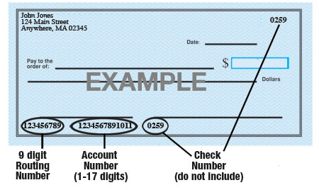

Name of Bank:

Account number:

9-Digit Routing number:

Amount: Entire Paycheck

Type of Account: Checking / Savings (Select One)

Homeland Language Services is hereby authorized to directly deposit my pay to the account listed above. This authorization will remain in effect until I modify or cancel it in writing.

Signature:

Date: